Cleaning Up at Home

After Work Each Day

Put pictures in order of the steps to clean up at home, after work each day and explain.
Step #______  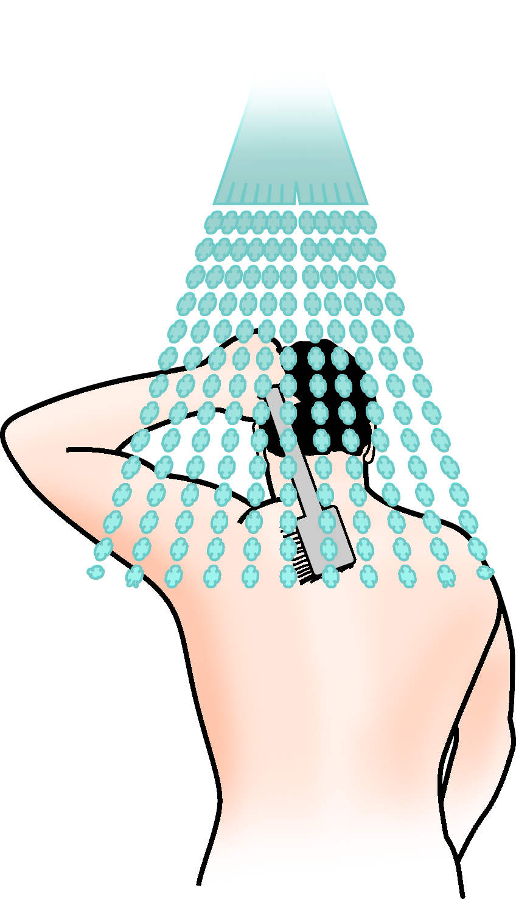  Shower | Step #_______  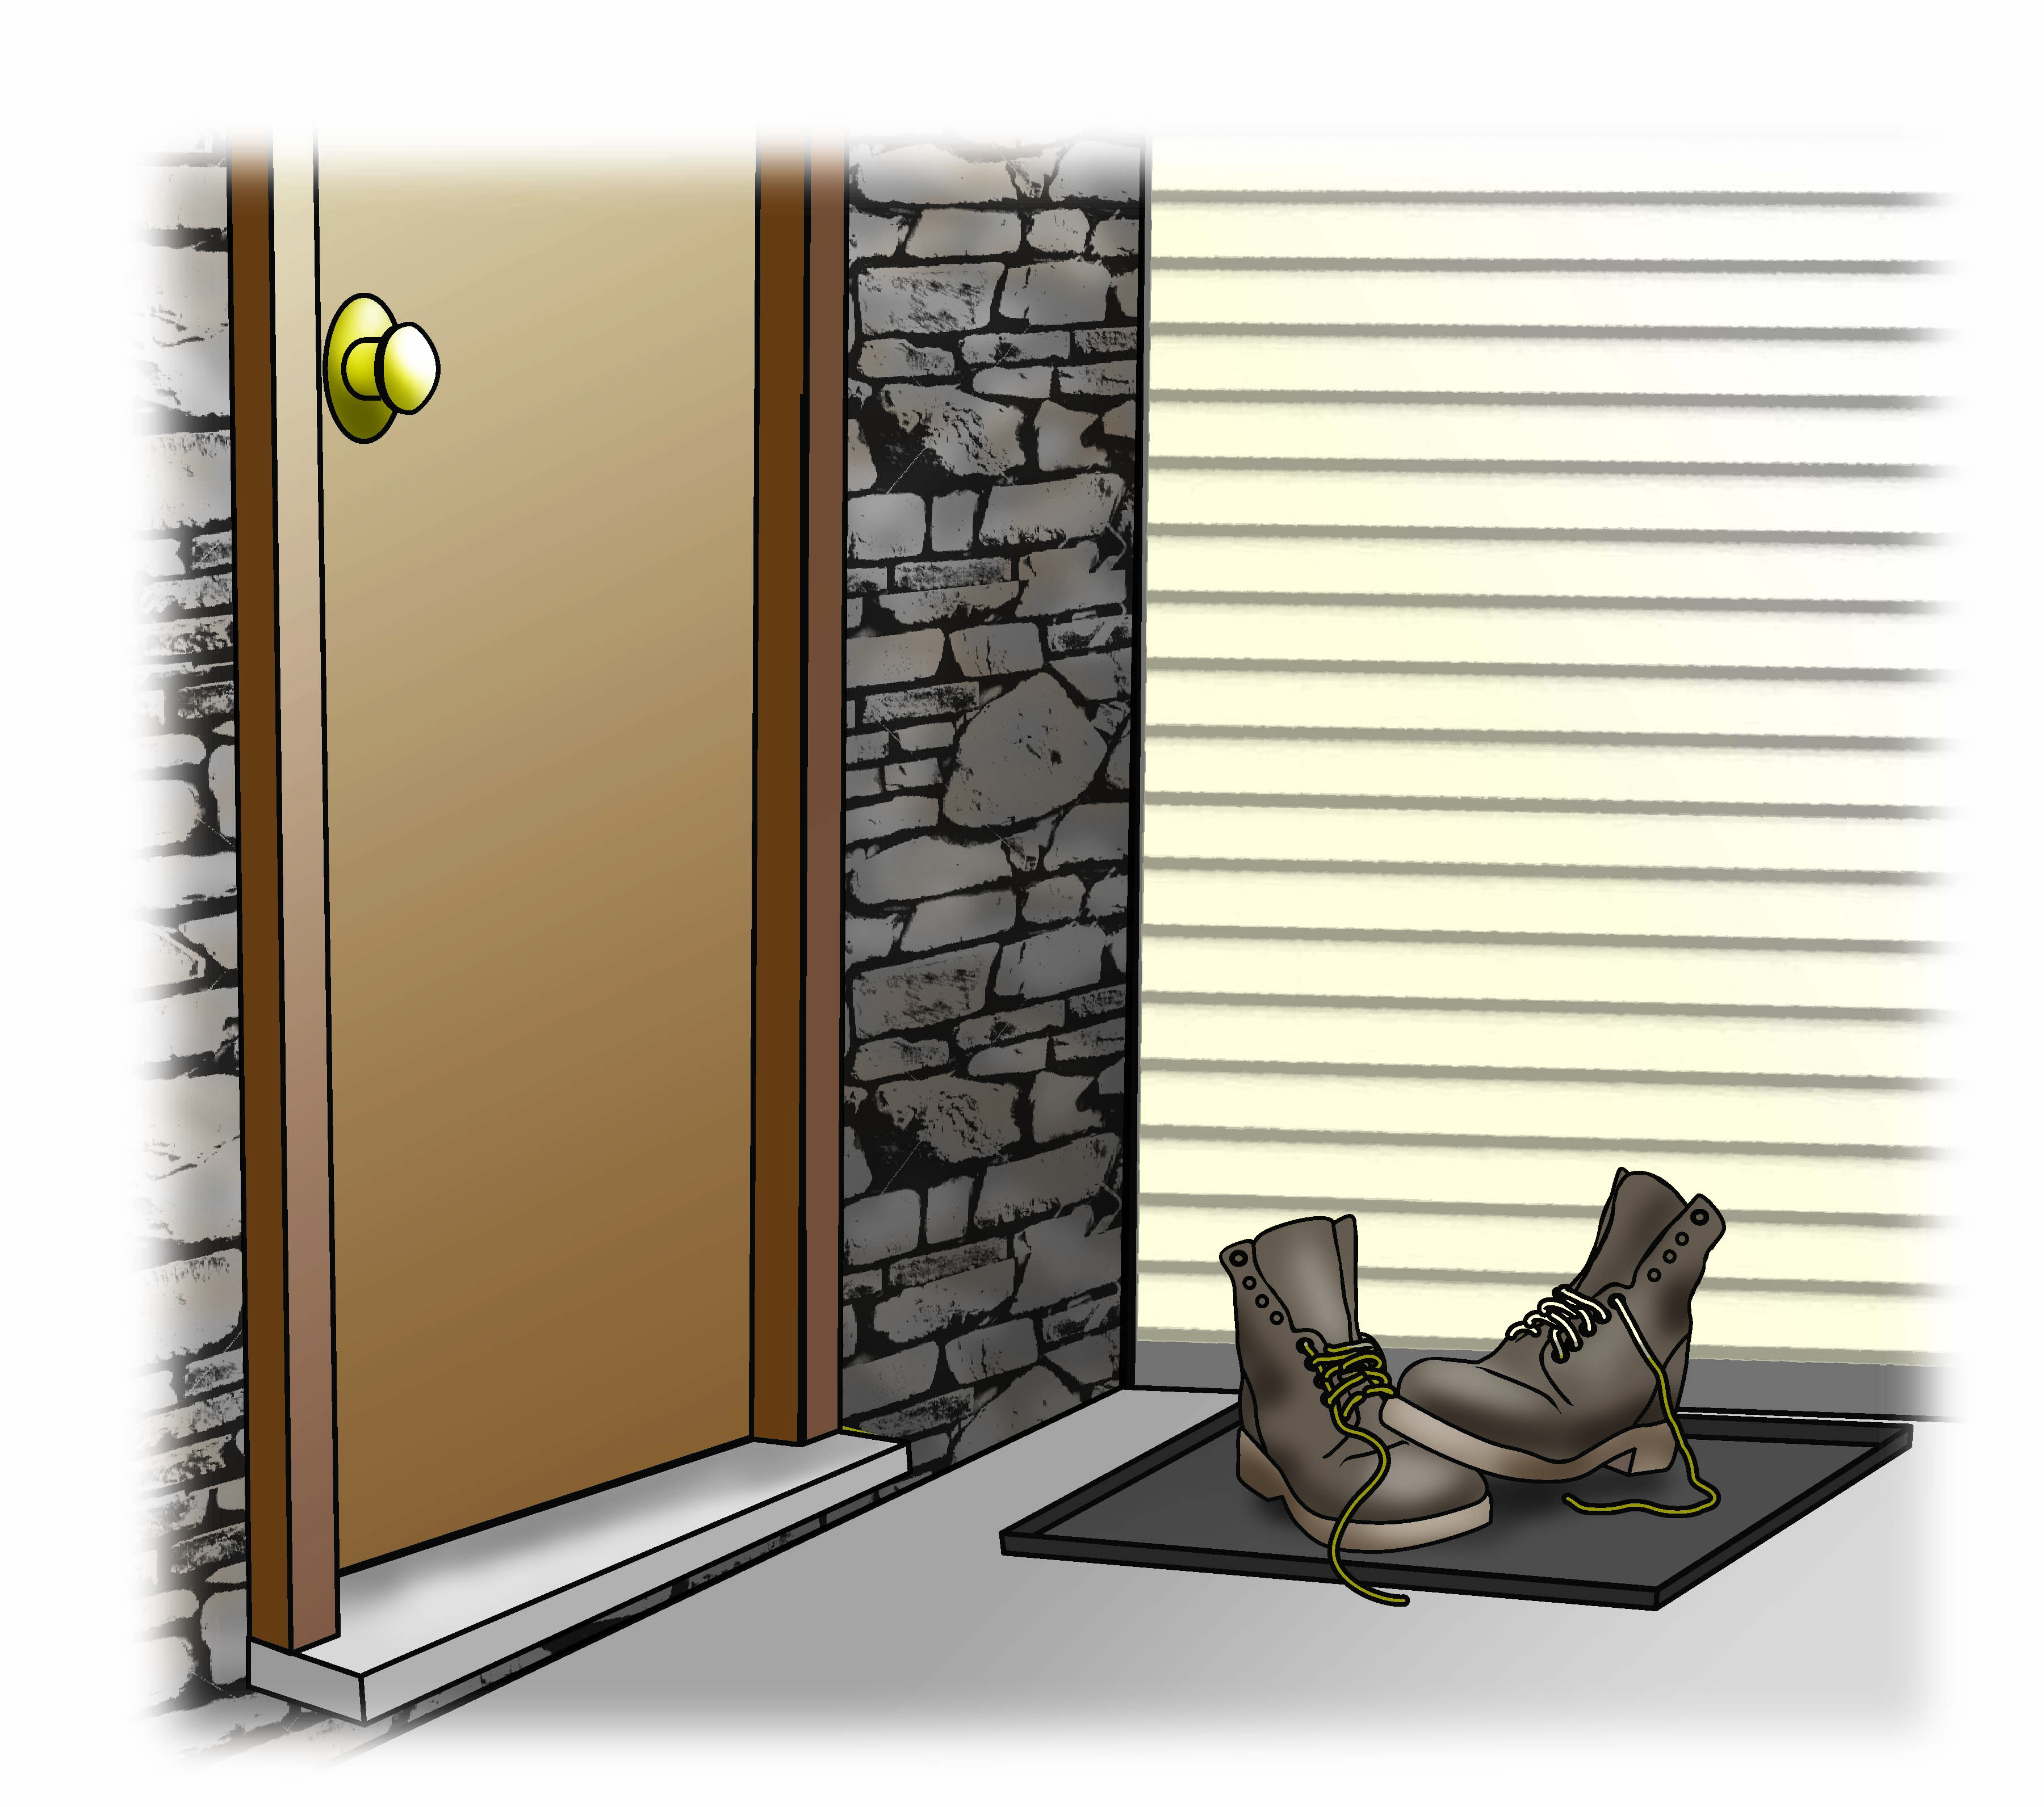  Boots off
Step #_______  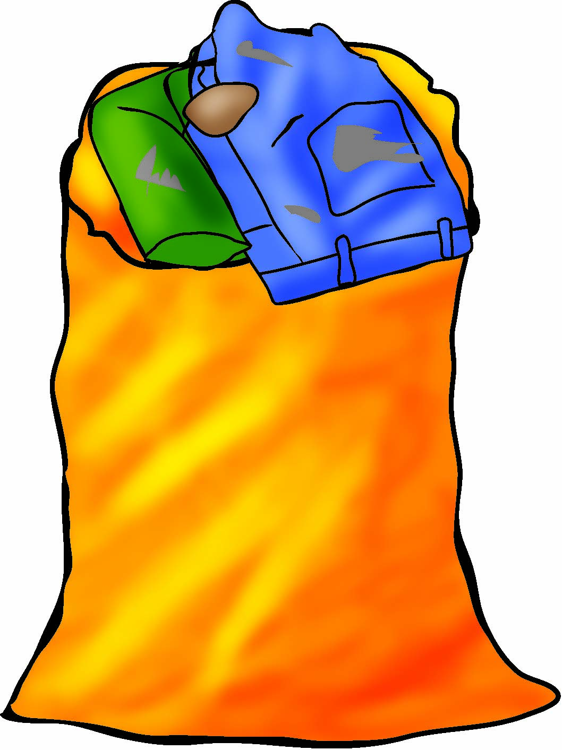  Dirty clothes | Step #_______  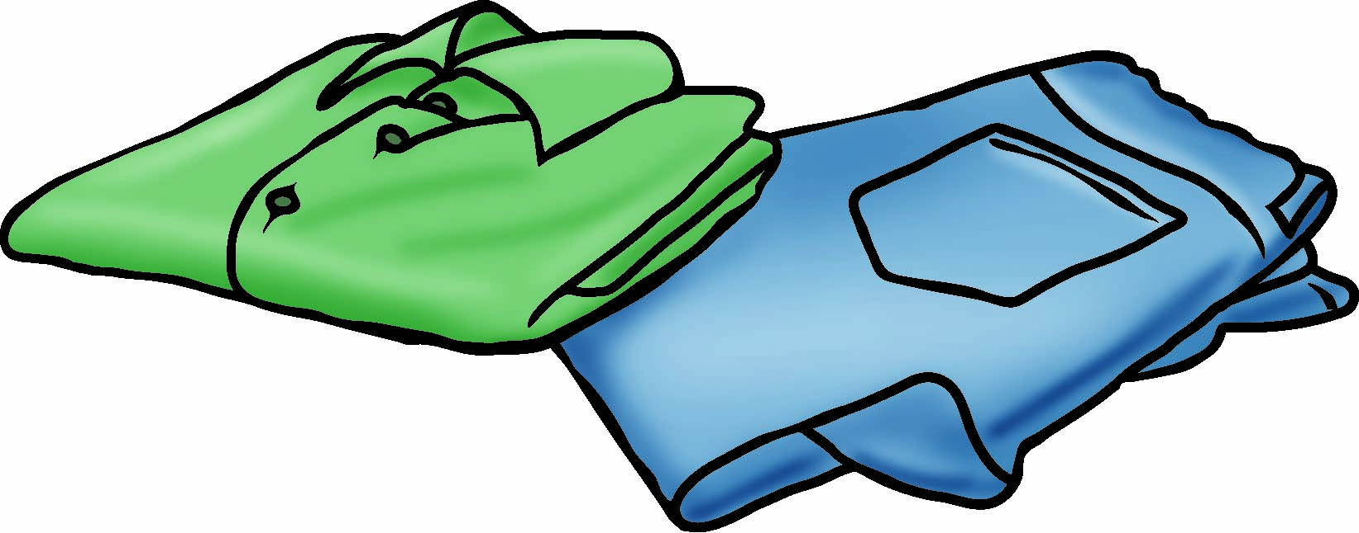  Clean clothes

